**NZ Bird Conference & AGM**

**Auckland, 31 May - 2 June 2025**

**Novotel & IBIS Auckland Ellerslie**

**72/112 Green Lane East, Ellerslie, Auckland**

**Registration Form**

A separate registration is required **for each person attending** and must be accompanied by the payment of specified costs. Online registration is available on: <https://www.birdsnz.org.nz/nz-bird-conference-2025/>

Title/Name______________________________________________ Region__________________________

Address_________________________________________________________________________________

E-mail __________________________________________________________________________________

Member ○ Non-member ○ Phone ( ) ________________ Mobile ____________________

**A Registration and Meals**

**A1 Conference Registration** *-* Covers attendance at one or both days, lunch, morning and afternoon tea

**Member Registration**

○ Early - both days (until 28 February) $290 $ _____

○ Late - both days (from 1 March to 16 May) $350 $ _____

○ 1 Day - Saturday 31 May only $185 $ _____

○ 1 Day - Sunday 1 June only $185 $ _____

**Student/Young Birder registration**

○ Both days $185 $ _____

○ 1 Day - Saturday 31 May only $100 $ _____

○ 1 Day - Sunday 1 June only $100 $ _____

**Non Member Registration**

○ Both days $475 $_____

○ 1 Day - Saturday 31 May only $255 $ _____

○ 1 Day - Sunday 1 June only $255 $ _____

**A2 Meals**

○ Saturday informal dinner $69 $ _____

○ Sunday conference dinner $79 $ _____

NB. For Field Trips no packed lunch is available – you will need to make your own arrangements. There is a Woolworths a short distance from the Novotel (326 Great South Road).

**Sub-Total A: Registration and Meals:** **$ ______**

Dietary: Please select items to be *excluded*

⚪ lactose; ⚪ gluten; ⚪ meat; ⚪ poultry; ⚪ fish; ⚪ eggs; ⚪ animal-derived

Other dietary notes: ____________________________________________________________________

**B Field Trips - Monday, 2 June**

Choose ONE of the following, as per details provided on the next page.

1. Tāwharanui Open Sanctuary $47 $ _____

2. Hauraki Gulf Pelagic [Max 14] $410 $ _____

3. Behind the Scenes at Auckland Museum [Max 10] $30 $ _____

4. Ambury Regional Park $30 $ _____

5. Tiritiri Matangi Island [own transport to city] $85.50 $ _____

**Sub-Total B: Field Trip:** **$ ______**

**C** **Fledgling Fund for Students - Donation**

Council approved that a ‘Fledgling Fund for Students’ be established to be used specifically to support the participation of student members for presenting papers or posters at Birds NZ conferences. The fund will be accumulative and dispersed in subsequent years. Members and non-members are invited to contribute $20, or more, to this fund when registering. Payment is optional and appreciated. The allocation of funds will be determined by Council each year.

**Sub-Total C: Fledgling Fund for Students - Donation:** **$ ______**

**TOTAL for A+B+C: *Please pay this amount:*  $_______**

**Payment**

1. The preferred option is to **register online** on <https://www.birdsnz.org.nz/nz-bird-conference-2025/> and pay by **direct deposit** to:

Ornithological Society Auckland

03-0166-0282247-001

be sure to include yoursurname in the particulars/reference code.

OR

2) Print this registration form, complete it, and mail it to: *Birds New Zealand Conference, c/- Gary Heaven, 591 Sandspit Road, RD2, Warkworth 0982, NZ.* Pay by direct deposit to the above bank account. Be sure to include yoursurname in the particulars/reference code.

Please note that your registration will not be confirmed until payment is received. Confirmation of your registration with a printable GST receipt will be made by e-mail, or by post if an e-mail address is not provided. Our GST number is: 49-411-923. All prices are GST inclusive.

**Refunds**:

Following registration, if you are unable to attend, a full refund will be made for cancellations advised up to **30 April** **2025**. From **1 May** **2025**, no refunds will be made. In the event of cancellation or re-selection of field trips, refund of the price difference will be made after the conference.

**Privacy Act**

The information on this form will be used solely for the purposes of organising and planning the conference including the publication of delegate lists. If you do not wish to have your name published as part of this conference or made available to other delegates, please advise us of this here.

○ I wish to have my name removed from all conference publications.

**Scientific Presentations**

Oral presentations will be spread across the first two days of the conference, and can cover any aspects of ornithology. Details and instructions are available on [www.birdsnz.org.nz/nz-bird-conference-2025/call-for-abstracts/](http://www.birdsnz.org.nz/nz-bird-conference-2025/call-for-abstracts/). Expressions of interest from members or non-members who wish to present a paper or a poster are welcomed. Abstracts of talks and posters should be submitted to [conference@birdsnz.org.nz](mailto:conference@birdsnz.org.nz) not later than **31 March 2025.**

○ I wish to make an **oral presentation** at the NZ Bird Conference 2025.  
○ I wish to **present a poster** at the NZ Bird Conference 2025.

**Field Trips**

On Monday 2 June, a variety of exciting field trips will be available:

**1. Tāwharanui Open Sanctuary**

Located on the scenic Tāwharanui Peninsula, this regional park is protected by a predator-proof fence and consists of a mosaic of forest, wetlands, beaches and ocean, and farmland. Much of the farmland has been revegetated, a process which is ongoing. Predator trapping/monitoring, bird monitoring and maintenance rely heavily on volunteer input. Existing species have been augmented by reintroductions.

We will leave the Novotel Ellerslie at 8.30 am for Tāwharanui, arriving around 10 am. On arrival we will be greeted by a head ranger from Auckland Council for an overview of the park. Then there will be free time to explore the different aspects of the park. Recommended are the lagoon area at Jones Bay, Anchor Bay, Ecology and Mangatawhiri Tracks. Key species include forest species such as North Island Saddleback, North Island Robin, Whitehead, plus Brown Teal, Banded Rail, Spotless Crake, Takahē and many others. Return from the park at 4 pm, arriving around 5.30 pm.

More information

<https://tossi.org.nz>

<https://www.aucklandcouncil.govt.nz/parkmaps/map-tawharanui-regional-park.pdf>

To keep costs down, please provide your own lunch and drinks. Walking is along well-formed tracks with little elevation gain, for as far as you wish.

Cost: $47.00 per person

**2. Hauraki Gulf Pelagic**

Our destination will be the vicinity of the Mokohinau Islands, north-west of Aotea - Great Barrier Island. A broad range of pelagic species can be expected including albatrosses, petrels, shearwaters, prions, and storm-petrels.

We will leave Novotel Ellerslie at 7:30am and travel to Sandspit (approximately 1 hour) then board the vessel ‘Norma Jean’. Transit time to the chumming area will be a little under 2 hours, but we will stop as opportunities arise if there are birds present. We will spend around 8 hours on the water, returning to Ellerslie around 6pm.

Please bring your own lunch and drinks with you. The boat has shelter but we recommend warm/wet weather gear to make the most of opportunities for viewing the birds.

Seasickness medication is advised.

Cost: $410.00 per person (limited to 14 participants)

**3. Behind the Scenes at Auckland Museum**

We will depart Novotel Ellerslie at 9am and return in time for the afternoon trips to Ambury. This is an opportunity to go behind the scenes at Auckland Museum to view rare specimens and learn about the invaluable work of this priceless collection. Following this relatively short visit, there will be time to explore the galleries and/or take in the ponds and gardens of the adjacent Domain. There is a cafe and gift shop at the museum.

The Behind-the-scenes visit is limited to 10 participants. Museum entry is free for Auckland residents. Visitors from outside Auckland are strongly encouraged to make a donation. There is a $32.00 entry fee for international visitors.

Cost: $30 per person [Limit 10 people]

**4. Ambury Regional Park**

We will depart Novotel Ellerslie at 1 pm and proceed to Ambury Regional Park to enjoy large numbers of waders, waterfowl, and other species. High tide is late afternoon which will allow time for exploring the mudflats and wetlands around Puketutu Island and the shell banks, which are a major high tide roost within the park. Walking to the shell-banks is along formed tracks, around 600 metres each way. Bring a telescope if you can.

Return around 5 pm.

More Information

<https://www.aucklandcouncil.govt.nz/parkmaps/map-ambury-regional-park.pdf>

Please bring your own lunch and drinks with you.

Cost: $30 per person

**5. Tiritiri Matangi**

One of the jewels of New Zealand’s conservation crown, Tiritiri Matangi is mostly naturally predator-free and other exotics have been eradicated. An Open Sanctuary, the motu (island) has benefited from massive revegetation projects and reintroductions of birds and other species. Such is the success of these species that they are now used as source populations for other translocations.

More Information

<https://www.tiritirimatangi.org.nz/>

The ferry departs from downtown Auckland (end of Quay St, diagonally across from the NZ Maritime Museum) at 8.30 am, picking up at Gulf Harbour (free parking available) at 9.25 am, arriving on the island at 9.50 am. The ferry leaves the island at 4pm, arriving back in Auckland at 5.20 pm. On arrival to Tiritiri Matangi there is a short mandatory biosecurity briefing, then you are free to explore the island.

A suggested route, if you have not been here before, is to take the Kawerau Track from the landing to the top of the island, then head toward the lighthouse. The suggested return route is the Wattle Track back to the landing. Walking is along well-maintained tracks, with an altitude gain of around 80 metres, then along the ridge to the Visitors’ Centre at the lighthouse. Here there is a gift shop and complimentary tea/coffee. Note there is no food available on the island.

Cost: $85.50 departing either from the Viaduct Harbour (downtown Auckland) or Gulf Harbour. Participants pay their own travel to their chosen departure point.

**Workshops**

Possible workshops we are considering running are listed below. Please tick any of these workshops that you would be interested in attending. This is to help in planning and does not commit you to attending at this stage (or us to offering this workshop).

**⭘ eBird Workshop**

An eBird Workshop will be held on Sunday 1st June, 8.15 - 8.45am in the conference room before the main events of the day

**⭘ Mist Netting and Banding Workshop, Monday 2nd June from 7am**

Run by well-known bird expert Adrian Riegen, the morning will be spent banding native and introduced passerines in an old West Auckland orchard. We expect to catch plenty of Silvereyes and a selection of other birds. An ideal opportunity for level 1 banders to gain some experience in setting mist nets, extracting and banding birds. Level 3 banders welcome to help with training. Restricted to 12 people, it will be weather dependent.

Own transport or car-pool, koha to driver.

**⭘ Drawing workshop at Ambury Park, Monday 2nd June**

Join Lesley Alexander, a nature artist from Auckland, for a fun workshop on sketching birds in the beautiful surroundings of Ambury Regional Park.

No previous drawing experience is necessary, and all materials will be provided. However, you’re welcome to bring your own sketchbook or watercolours if you prefer.

Cost $60 (including transport)

**Travel**

Please book early for cheap flights to Auckland*.* There are taxis, ride share service and shuttles available from the airport. On most flights there will be others coming to the conference who could share costs, so look out for each other on arrival.

The venue and accommodation are located adjacent to Greenlane off ramp on the Southern Motorway. The travel time is 10 minutes from Auckland’s CBD, Newmarket and Remuera and is 30 minutes from the airport.

If you are travelling by car using GPS, the venue is accessed at the rear entrance at **“85 Ascot Avenue, Remuera”**.

The venue is a short walk from the Greenlane Train Station on Great South Road. Use the AT Journey Planner to plan your public transport. The AT Journey Planner is available on line at <https://at.govt.nz/bus-train-ferry/journey-planner> or may be downloaded as an app onto your phone. We anticipate that Auckland Transport will have implemented credit card payment by the time the conference is running. This avoids the need to purchase an ATHOP card to use public transport. Please note that Buses will replace trains on the holiday weekend as part of the planned track maintenance programme for 2025.

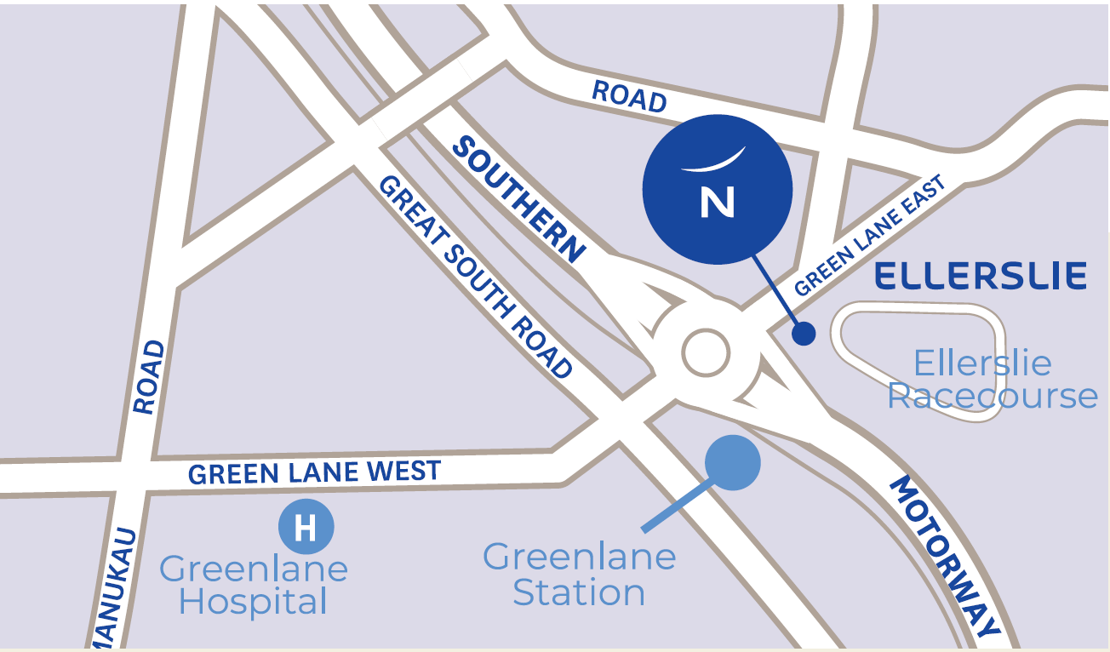

**Accommodation**

The conference will be held at the Novotel & IBIS Auckland Ellerslie hotel. We have arranged concessionary rate accommodation at the venue. The hotel offers 4 ½ star Novotel rooms or 3 ½ star IBIS rooms.

Novotel Auckland Ellerslie

72 – 112 Greenlane East, Ellerslie, Auckland

Phone +64 (09) 529 9090

Please book using this link <https://accorevents.com/offers/birds2025>

There is also a range of alternative accommodation within a few minutes walk from the conference venue.

Greenlane Suites (3.5 Star Hotel) <https://www.cpghotels.com/hotels/greenlane-suites/>

Auckland Central Motel (across road) <https://www.aucklandcentralmotel.com/>

The Devereux (Bed & Breakfast) <https://thedevereux.co.nz/home>

La Quinta by Wyndham (4 Star Hotel) <https://laquintaellerslie.co.nz/>

Best Western Ellerslie International Motel <https://www.eimi.co.nz/>

Greenlane Manor Motel (Motel) <https://www.greenlanemanor.co.nz/>

Auckland Phoenix Palm Motel (Budget Motel) <https://aucklandphoenixpalmmotel.co.nz/>

Touchwood Camp (Motel Units, Cabins & Powered Motorhome Sites) <https://camp.motorlodge.nz/>

Touchwood Camp is one of the very few Holiday Park type places in Auckland City and is located 1.7km away (a 24-minute walk). It would be a great place for anyone with a motorhome.

Reservations should be made with the accommodation of your choice. Location maps are shown on their websites.

**Application for Fledgling Fund Grant**

Student Members of Birds New Zealand are invited to apply for a grant from The Fledgling Fund to cover their conference registration fee and attendance of the conference dinner.

Applicants must have been a Student Member of Birds New Zealand for two or more years and enrolled full-time at a NZ tertiary institution or secondary school. A grant from the Fledgling fund shall only be made once to each Student Member.

Download the criteria and application form [here](https://www.birdsnz.org.nz/wp-content/uploads/2021/11/2022-Fledgling-Fund-Grant-Application-Form.doc). Applications should be submitted to the Executive Officer [eo@birdsnz.org.nz](mailto:eo@birdsnz.org.nz) by **28 February**.

**Contacts**

You can contact the conference organisers via [conference@birdsnz.org.nz](mailto:conference@birdsnz.org.nz), by phone Gary Heaven 021 896698. Alternatively, contact your Regional Representative <https://www.birdsnz.org.nz/contact/>

**Notes**

**Disclaimer**  
In the event of unforeseen circumstances (industrial or otherwise) that disrupt the conference, the organisers accept no responsibility. The information on the conference website and in the printed material is correct at the time of publication. However, the conference organisers reserve the right to change information if required and to adjust the conference programme accordingly.

*Updated 2024-11-20*